COMPUTER ARCHITECTURE & SYSTEMS LAB

Day 3 Assignment: RAM & Storage Systems
Topic: Volatile vs. Non-Volatile Memory Topologies, Generational Memory Deltas, and Physical Media Interfaces
TASK 1: MEMORY ARCHITECTURE COMPARISON
1. Generational RAM Standards Matrix (DDR3 vs. DDR4 vs. DDR5)
Synchronous Dynamic Random-Access Memory (SDRAM) has evolved rapidly to reduce operating voltages, maximize data bandwidth, and handle high core-count processor signaling paths.

Specification | DDR3 Memory | DDR4 Memory | DDR5 Memory
Data Rates / Speed | 800 MT/s to 2133 MT/s | 1600 MT/s to 3200 MT/s | 4800 MT/s to 8400+ MT/s
Operating Voltage | 1.5V Standard (1.35V Low Voltage) | 1.2V Base Architecture | 1.1V Base (On-DIMM  PMIC regulation)
Channel Layout | Single 64-bit wide sub-channel | Single 64-bit wide sub-channel | Dual independent 32-bit sub-channels
Typical Use Cases | Legacy systems (e.g., Intel Core 3rd/4th Gen), older office PCs, thin clients. | Standard modern desktops, gaming systems, enterprise workstations (DDR4 server nodes). | Next-gen computing, heavy data compilation, real-time AI modeling, 4K/ 8K video production.

TASK 2: PRACTICAL LAB COMPONENT

RAM Extraction and Reinstallation Documentation

SAFETY PROTOCOL: Disconnect all AC power cords, extract the internal battery if servicing a laptop, and ground yourself against electrostatic discharge (ESD) prior to interacting with the components.

[Student Lab Documentation — Installed RAM Module Verification]
Insert a clear photo showing the memory module seated inside your device's DIMM/SO-DIMM slot.
Ensure the alignment notch position or the module labeling is legible.

3. Mechanical vs. Solid-State Storage Analysis

Storage hierarchies balance raw capacity costs against input/output operations per second (IOPS) and data bus latencies.
Storage Interface | Key Architectural Deltas & Speed Profiles | Optimized Target Application
 |  | Mass Cold Backup Data
 | Mechanical spinning magnetic platters read by | Storage
Hard Disk Drive | an actuator arm. Prone to mechanical shock. | Archiving vast raw
(HDD) | Maximum operational sequential throughput tops | multimedia media files or
 | out near ~150–250 MB/s. High seek times. | system backups where
 |  | latency is secondary.
 | Flash NAND memory architecture bound to the | Operating System
SATA Solid-State Drive (SSD) | legacy SATA legacy controller protocol. Caps out structurally at an interface ceiling of ~550–600  MB/s due to link limitations. Zero moving | Upgrades  Revitalizing legacy hardware systems lacking native M.2
 | components. | motherboard slots.
 |  | Modern Gaming & IDE
 | Flash NAND running on the Non-Volatile | Workloads
NVMe Solid-State Drive (PCIe) | Memory Express standard communicating over direct high-bandwidth PCIe pathways. Achieves  sequential reads from 3,500 MB/s to 14,000+ | Instant loading in asset-heavy software engine  environments (e.g., modern
 | MB/s. Ultra-low queue latency. | games or local database
 |  | compilation).

TASK 4: STORAGE INFRASTRUCTURE MAINTENANCE

Non-Volatile Drive Interface Removal Log

System Reassembly Post-Mortem Verification:
Upon seating the memory sticks completely into the retention mechanisms and clamping down the latch locks, the machine successfully passed the Power-On Self-Test (POST). System memory registration parameters confirm full configuration density at native speeds in the OS Task Manager.

TASK 3: NON-VOLATILE STORAGE TYPOLOGIES

Verification Step: Safely pull out your system's primary storage block or identify the physical form factor of your equipment via an approved manufacturer deployment framework documentation process.
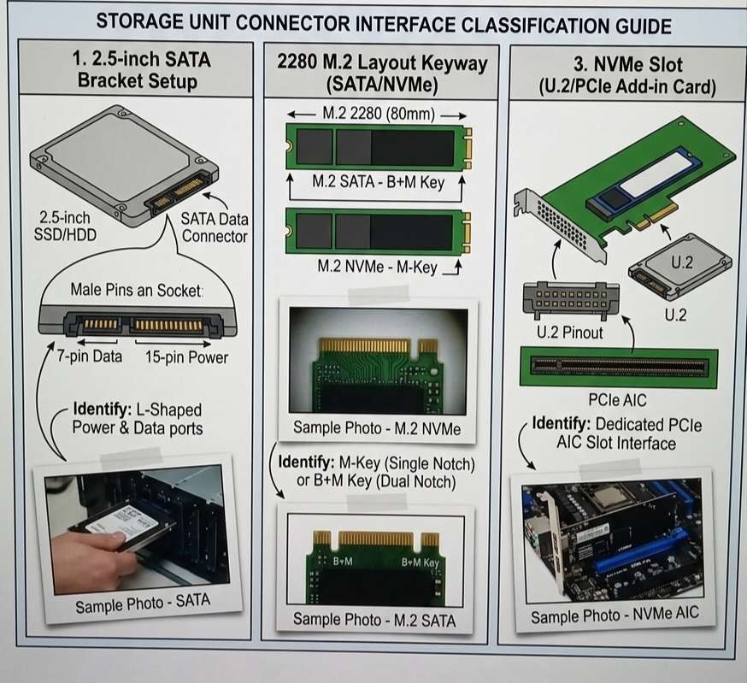

[Student Lab Documentation — Storage Unit Connector Interface]
Insert a photographic trace or video process link demonstrating the drive pin connector footprint.
Identify if it uses a 2.5-inch SATA bracket setup, a 2280 M.2 layout keyway, or an NVMe slot channel.

:

Device Storage Layout Structure Classification: (e.g., M.2 M-Key NVMe PCIe Gen 4 / 2.5-inch SATA Data and Power Interface Header). Internal BIOS utility registers the drive index correctly following reassembly.

